FORM 1  THE PATENTS ACT, 1970  (39 of 1970)  &  THE PATENTS RULES, 2003  APPLICATION FOR GRANT OF PATENT  (See sections 7, 54 & 135 and rule 20(1)) |  |  |  |  |  |  |  |  |  |  | (FOR OFFICE USE ONLY)  Application No.:  Filing Date:  Amount of Fee paid:  CBR No.:  Signature:
1. APPLICANT’S REFERENCE / IDENTIFICATION NO. (AS ALLOTTED BY OFFICE)

2. TYPE OF APPLICATION [Please tick (✔) at the appropriate category]
Ordinary (✔) |  |  |  |  |  |  | Convention ( ) |  |  |  |  |  |  |  | PCT-NP ( )
Divisional ( ) | Patent of Addition ( ) |  |  |  |  |  | Divisional ( ) |  |  | Patent of Addition ( ) |  |  |  |  | Divisional ( ) |  |  | Patent of Addition ( )
3A. APPLICANT(S)
Name in Full |  |  |  | Nationality |  |  |  | Country of Residence |  |  |  |  | Address of the Applicant
Gujarat Council on Science and Technology (GUJCOST) |  |  |  | INDIAN |  |  |  | INDIA |  |  |  |  | House No. |  |  |  | Block B, 7th Floor
 |  |  |  |  |  |  |  |  |  |  |  |  | Street |  |  |  | M. S. Building, Nr. Pathikashram, Sector 11, Gandhinagar, Gujarat - 382011, India
 |  |  |  |  |  |  |  |  |  |  |  |  | City |  |  |  | Gandhinagar
 |  |  |  |  |  |  |  |  |  |  |  |  | State |  |  |  | Gujarat
 |  |  |  |  |  |  |  |  |  |  |  |  | Country |  |  |  | India
 |  |  |  |  |  |  |  |  |  |  |  |  | Pin Code |  |  |  | 382011
Indian Institute Of Technology, Bhubabneswar |  |  |  | INDIAN |  |  |  | INDIA |  |  |  |  | House No.
 |  |  |  |  |  |  |  |  |  |  |  |  | Street |  |  |  | Argul (Jatni)
 |  |  |  |  |  |  |  |  |  |  |  |  | City |  |  |  | Khordha
 |  |  |  |  |  |  |  |  |  |  |  |  | State |  |  |  | Odisha
 |  |  |  |  |  |  |  |  |  |  |  |  | Country |  |  |  | India
 |  |  |  |  |  |  |  |  |  |  |  |  | Pin Code |  |  |  | 752050
3B. CATEGORY OF APPLICANT [Please tick (✔ ) at the appropriate category]
 |  |  |  |  | Other than Natural Person
Natural Person ( ) |  |  |  |  | Small Entity ( ) |  |  |  | Startup ( ) |  |  |  | Educational Institution ( ) |  |  |  |  |  | Others (✔)
4. INVENTOR(S) [Please tick (✔) at the appropriate category]
Are all the inventor(s) same as the applicant(s) named above? |  |  |  |  | Yes ( ) |  |  |  |  |  |  |  |  | No (✔)
Name in Full |  |  |  | Nationality |  |  |  | Country of Residence |  |  |  |  | Address of the Applicant
Dr. Yogesh G. Bhumkar |  |  |  | INDIAN |  |  |  | INDIA |  |  |  |  | House No.
 |  |  |  |  |  |  |  |  |  |  |  |  | Street |  |  |  | Argul (Jatni)
 |  |  |  |  |  |  |  |  |  |  |  |  | City |  |  |  | Khordha
 |  |  |  |  |  |  |  |  |  |  |  |  | State |  |  |  | Odisha
 |  |  |  |  |  |  |  |  |  |  |  |  | Country |  |  |  | India
 |  |  |  |  |  |  |  |  |  |  |  |  | Pin Code |  |  |  | 752050
Prabhuparth Choudhar |  |  |  | INDIAN |  |  |  | INDIA |  |  |  |  | House No.
 |  |  |  |  |  |  |  |  |  |  |  |  | Street |  |  |  | Argul (Jatni)
 |  |  |  |  |  |  |  |  |  |  |  |  | City |  |  |  | Khordha
 |  |  |  |  |  |  |  |  |  |  |  |  | State |  |  |  | Odisha
 |  |  |  |  |  |  |  |  |  |  |  |  | Country |  |  |  | India
 |  |  |  |  |  |  |  |  |  |  |  |  | Pin Code |  |  |  | 752050
Divyang Vegda |  |  |  | INDIAN |  |  |  | INDIA |  |  |  |  | House No.
 |  |  |  |  |  |  |  |  |  |  |  |  | Street |  |  |  | Argul (Jatni)
 |  |  |  |  |  |  |  |  |  |  |  |  | City |  |  |  | Khordha
 |  |  |  |  |  |  |  |  |  |  |  |  | State |  |  |  | Odisha
 |  |  |  |  |  |  |  |  |  |  |  |  | Country |  |  |  | India
 |  |  |  |  |  |  |  |  |  |  |  |  | Pin Code |  |  |  | 752050
Palash Jain |  |  |  | INDIAN |  |  |  | INDIA |  |  |  |  | House No.
 |  |  |  |  |  |  |  |  |  |  |  |  | Street |  |  |  | Argul (Jatni)
 |  |  |  |  |  |  |  |  |  |  |  |  | City |  |  |  | Khordha
 |  |  |  |  |  |  |  |  |  |  |  |  | State |  |  |  | Odisha
 |  |  |  |  |  |  |  |  |  |  |  |  | Country |  |  |  | India
 |  |  |  |  |  |  |  |  |  |  |  |  | Pin Code |  |  |  | 752050
Mihir V. Khunti |  |  |  | INDIAN |  |  |  | INDIA |  |  |  |  | House No.
 |  |  |  |  |  |  |  |  |  |  |  |  | Street |  |  |  | Argul (Jatni)
 |  |  |  |  |  |  |  |  |  |  |  |  | City |  |  |  | Khordha
 |  |  |  |  |  |  |  |  |  |  |  |  | State |  |  |  | Odisha
 |  |  |  |  |  |  |  |  |  |  |  |  | Country |  |  |  | India
 |  |  |  |  |  |  |  |  |  |  |  |  | Pin Code |  |  |  | 752050
5. TITLE OF THE INVENTION: SAFE-DRONE - Swarm Based Autonomous Field Clearance and Escort DRONE System
6. AUTHORISED REGISTERED PATENT AGENT(S) |  |  |  |  |  |  |  |  |  |  |  | IN/PA No. -  Name -  Mobile No. -
7. ADDRESS FOR SERVICE OF APPLICATION IN INDIA |  |  |  |  |  |  |  |  |  |  |  | Name Dr. Narottam Sahoo  Postal Address Patent Information Centre (PIC), Gujarat Council on Science and Technology (GUJCOST), Block B, 7th Floor, M. S. Building, Nr. Pathikashram, Sector 11, Gandhinagar, Gujarat – 382011, India  Telephone No. -  Mobile No. +91-9426490755  Fax. No. -  E-mail ID pic-gujcost@gujarat.gov.in
8. IN CASE OF APPLICATION CLAIMING PRIORITY OF APPLICATION FILED IN CONVENTION COUNTRY, PARTICULARS OF CONVENTION APPLICATION
Country |  | Application Number |  |  |  | Filing Date |  |  | Name of the Applicant |  |  |  | Title of the Invention |  |  |  |  |  | IPC(as classified in the convention country)
- |  | - |  |  |  | - |  |  | - |  |  |  | - |  |  |  |  |  | -
9. IN CASE OF PCT NATIONAL PHASE APPLICATION, PARTICULARS OF INTERNATIONAL APPLICATION FILED UNDER PATENT CO-OPERATION TREATY (PCT)
International Application Number |  |  |  |  |  |  |  |  |  | International filing date
- |  |  |  |  |  |  |  |  |  | -
10. IN CASE OF DIVISIONAL APPLICATION FILED UNDER SECTION 16, PARTICULARS OF ORIGINAL (FIRST) APPLICATION

Original (first) application No. |  |  |  |  |  |  |  |  |  | Date of filing of original (first) application
- |  |  |  |  |  |  |  |  |  | -
11. IN CASE OF PATENT OF ADDITION FILED UNDER SECTION 54, PARTICULARS OF MAIN APPLICATION OR PATENT

Main Application/Patent Number |  |  |  |  |  |  |  |  |  | Date of filing of main application
- |  |  |  |  |  |  |  |  |  | -
12. DECLARATIONS

(i) Declaration by the inventor(s)
(In case the applicant is an assignee: the inventor(s) may sign herein below or the applicant may upload the assignment or enclose the assignment with this application for patent or send the assignment by post/electronic transmission duly authenticated within the prescribed period).

We, the above named inventor(s) are the true & first inventor(s) for this invention and declare that the applicant herein is our assignee or legal representative.

(a) Date: 16th February 2026 | 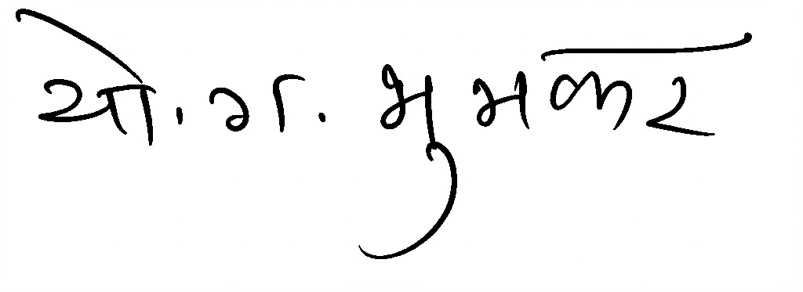  (b) Signature:  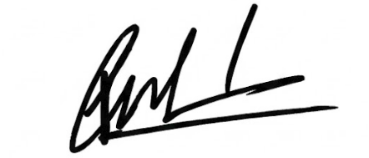  (c) Name: Dr. Yogesh G. Bhumkar  (b) Signature:  (c) Name: Prabhuparth Choudhar  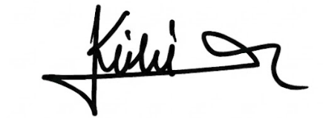  (b) Signature:  (c) Name: Mihir V. Khunti  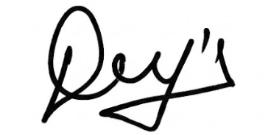  (b) Signature:  (c) Name: Divyang Vegda  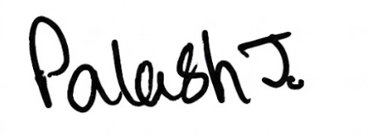  (b) Signature:  (c) Name: Palash Jain

☒(ii) Declaration by the applicant(s) in the convention country

(In case the applicant in India is different than the applicant in the convention country: the applicant in the convention country may sign herein below or applicant in India may upload the assignment from the applicant in the convention country or enclose the said assignment with this application for patent or send the assignment by post/electronic transmission duly authenticated within the prescribed period).

I / We, the applicant(s) in the convention country declare that the applicant(s) herein is/ are my / our assignee or legal representative.

(a) Date :  (b) Signature :  (c) Name : | (a) Date :  (b) Signature :  (c) Name :

(iii) Declaration by the Applicant(s)
I/We, the applicant(s) hereby declare(s) that :-
☑ I am/We are in possession of the above-mentioned invention.
☑ The provisional/complete specification relating to the invention is filed with this application.
☒ The invention as disclosed in the specification uses the biological material from India and the necessary permission from the competent authority shall be submitted by me /us before the grant of patent to me/us.
☑ There is no lawful ground of objection(s) to the grant of the Patent to me/ us.
☒ I am /We are the true & first inventor(s).
☑ I am /We are the assignee or legal representative of true & first inventor(s).
☒ The application or each of the applications, particulars of which are given in Paragraph-8, was the first application in convention country/countries in respect of my/our invention(s).
☒ I/We claim the priority from the above mentioned application(s) filed in convention country/countries and state that no application for protection in respect of the invention had been made in a convention country before that date by me/us or by any person from which I/We derive the title.
☒ My/our application in India is based on international application under Patent Cooperation Treaty (PCT) as mentioned in Paragraph-9.
☒ The application is divided out of my/our application particulars of which is given in Paragraph-10 and pray that this application may be treated as deemed to have been filed on ____________. under section 16 of the Act.
☒ The said invention is an improvement in or modification of the invention particulars of which are given in Para-11.
13. FOLLOWING ARE THE ATTACHMENTS WITH THE APPLICATION
- Form 2
Item |  |  | Details |  |  |  |  |  |  | Fee |  |  |  |  |  | Remarks
Complete Specification |  |  | No. of pages:
No. of Claim(s) |  |  | No. of claims and No. of pages:
Abstract |  |  | No. of pages:
No. of Drawing(s) |  |  | No. of drawings and No. of pages:
☒ Complete specification (in conformation with the international application) / as amended before the International Preliminary Examination Authority (IPEA), as applicable (2 copies), No. of pages ______, No. of claims_________.
☒ Sequence listing in electronic form
☒ Drawings (in conformation with the international application)/as amended before the International Preliminary Examination Authority (IPEA), as applicable (2 copies), No. of sheets ___________
☒ Priority document(s) or a request to retrieve the priority document(s) from DAS (Digital Access Service) if the applicant had already requested the office of first filing to make the priority document(s) available to DAS.
☒ Translation of priority document/Specification/International Search Report/International Preliminary Report on Patentability.
☑ Statement and Undertaking on Form 3
☑ Declaration of Inventorship on Form 5
☒ Power of Authority
Total fee Rs. ________ in Bank Draft bearing no. __________Date _________ on State Bank of India.

I/We hereby declare that to the best of my/our knowledge, information and belief the fact and matters stated herein are correct and I/We request that a patent may be granted to me/us for the said invention.

Dated this day of

Signature:  Name: Dr. Narottam Sahoo  Advisor and Member Secretary  Gujarat Council on Science and Technology  Dept. of Science and Technology, GoG. | 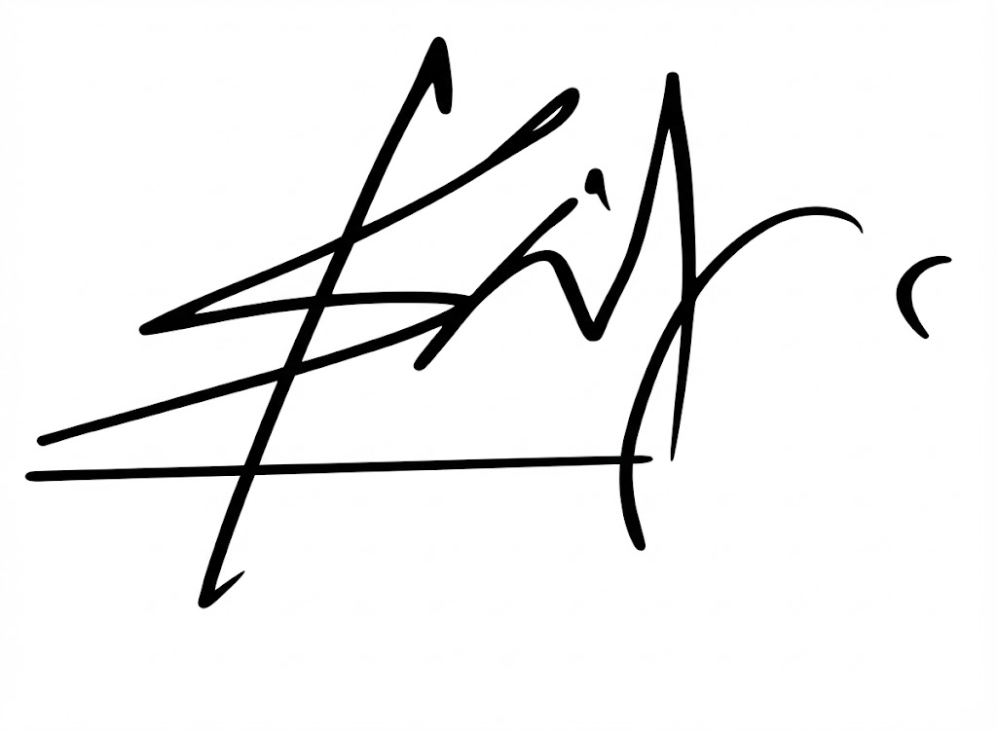  Signature:  Name: Prof. Shantanu Pal  Dean, Under Graduate Programs  IIT Bhubaneswar    Seal:

To,
The Controller of Patents
The Indian Patent Office, Mumbai

